By the end of this video you’ll have a knowledge base of some key terms that will be mentioned throughout the next series of videos and frequently used in C# programming Language .

Topics for this video will include components such as using statements, namespace in relation to an assembly or project, the C# class as building block, methods, and variable-fields.

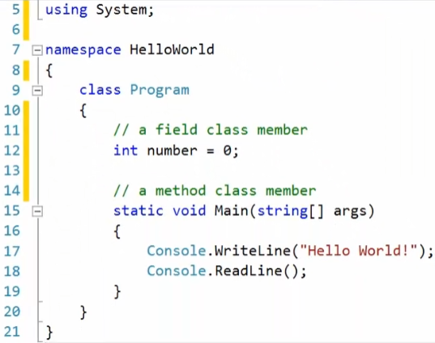Here we are in visual studio As you can see here I have the “hello world” program from the previous video open

As you build a program, you’ll be creating many new files with the “C-S” file extension, to group related classes and code.

In this example I have program.cs file open

We are going to go thru each line of code starting at the top with the using statement, which is a reference to one of many libraries of the .NET Framework

Here we are referencing the **System Namespace** which provides the Console class, which includes the WriteLine and ReadLine methods and many more methods.

If you are familiar with Java or C++, **using statement** is analogous to import or include statements.

On the next line the **keyword namespace** is for organizing the code for this program or your program. That way multiple code files that are related can be grouped together. It prevents naming conflicts and thus allowing 2 classes with the same name to exist in different namespaces within the same project.

Next is the class definition at line 9, which starts with the keyword class and the title of this class is Program.

In C# almost everything is an object and the “class” keyword is how to define and create these objects, which we’ll discuss in more detail in further videos.

Inside classes, there can be multiple members of various types and functionality.

At the top of this class is an example of a field or variable. For now, understand that a field is a variable for holding a data value.

The next class member is a method that provides a snippet of functionality. In this example, the Main method is a special function that .NET uses as a starting point for running your program.

At line 15 is the declaration for Main method. For now don’t worry about the words “static”, “void”, “string”, and short hand arguments “A-R-G-S”.

Also, the word “Main” is always uppercase.

Between the curly brackets is we start to write code. Here, I have 2 statements that begin with the built-in Console object – Provided by the .NET System library – to invoke the WriteLine and ReadLine methods.

If you remember The WriteLine method prints out the string between the double quotes to the screen, and ReadLine waits and listens for user input.

In addition, notice that each statement ends with a semicolon, like a sentence ending with a period or other punctuation.

In this project, I created another object and I’ll switch the code editor to open up the Robot class.

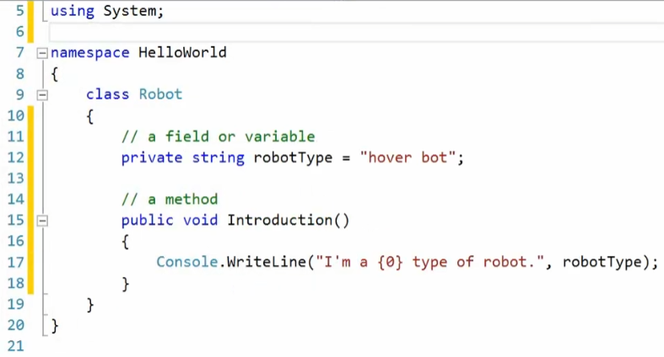This class has similar components to the Program class; at the top is the same using statement, and both classes exist in the same namespace.

If this project was compiled into a package it would contain both the Program and Robot classes in an assembly called HelloWorld.

Inside the Robot class definition is a field or variable called robot type,

which we’ll discuss in more detail in the Data Types video: how to declare and assign variable

And there is a method called Introduction which we’ll discuss in more detail in future video.

In both classes, there is text that is in green and these comments preceded by 2 forward slash characters which the compiler will ignore at compile time yet useful for you to provide a brief description for a few lines of code, the purpose of a variable, the behavior of a method, and explanation of a class.

Also I want to point out the indentation and whitespace which is our benefit to see how a class structured.

For instance, at line 17 the code statement which invokes a call to WriteLine method, is with the code block for the Introduction method.

Now The indentation provides clarity that the robot type field and Introduction method are declared within in the Robot class.

To recap, in this video we explained some of a program’s components, such as using statement, class definitions, class member fields and methods.

Also, mentioned code comments, syntax such as indentation for readability,

and how namespace can be use to organize groups of C# classes into multiple files.

All the material Present in this video are real by eintern online